**Diploma in Native Application Assignment**

**MODULE: 5**

**DATABASE**

**Name: Patel Avi N.**

**What do you understand By Database.**

* + A database is an organized collection of structured information stored electronically. It is designed to efficiently manage, store, retrieve, and manipulate data.

1. **What is Normalization?**
   * Normalization is the process of organizing data in a database to minimize redundancy and dependency. It involves breaking down large tables into smaller, related tables to reduce data redundancy and improve data integrity.
2. **What is Difference between DBMS and RDBMS?**
   * **DBMS (Database Management System):** It is a software that manages databases. It provides an interface to interact with databases but may not enforce relationships between tables or support complex querying.
   * **RDBMS (Relational Database Management System):** It is a type of DBMS that manages data based on the relational model. RDBMS enforces relationships between tables using keys and supports SQL for complex querying.
3. **What is MF Cod Rule of RDBMS Systems?**
   * There is no widely recognized "MF Cod Rule" in RDBMS systems. It might be a typo or an unknown term.
4. **What do you understand By Data Redundancy?**
   * Data redundancy refers to the repetition of data in a database. It occurs when the same piece of data is stored multiple times, leading to inefficiency and possible inconsistencies.
5. **What is DDL Interpreter?**
   * DDL (Data Definition Language) Interpreter processes and executes statements that define the structure of a database, such as creating, modifying, or dropping database objects like tables, indexes, etc.
6. **What is DML Compiler in SQL?**
   * DML (Data Manipulation Language) Compiler translates and executes statements that manipulate data in the database, such as SELECT, INSERT, UPDATE, DELETE operations.
7. **What is SQL Key Constraints writing an Example of SQL Key Constraints**
   * SQL Key Constraints enforce rules for columns in a table. Examples include:
   * PRIMARY KEY: Uniquely identifies each record in a table.
   * FOREIGN KEY: Enforces referential integrity between two related tables.
   * UNIQUE KEY: Ensures that all values in a column are different.
8. **What is save Point? How to create a save Point write a Query?**
   * A save point is a point in a transaction when you can mark the transaction so that you can roll back to that point without rolling back the entire transaction. Example query to create a save point
   * SAVEPOINT my_savepoint;
9. **What is trigger and how to create a Trigger in SQL?**
   * A trigger is a set of SQL statements that automatically "fires" or executes when a specific event occurs in the database (e.g., INSERT, UPDATE, DELETE). It's used to enforce business rules or perform actions based on certain database events. Example of creating a trigger:
   * CREATE TRIGGER my_trigger

AFTER INSERT ON my_table

FOR EACH ROW

BEGIN

-- Trigger action/statements here

-- For example: INSERT INTO another_table VALUES (NEW.column_name);

END;

Task

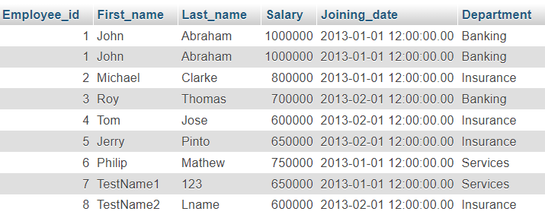

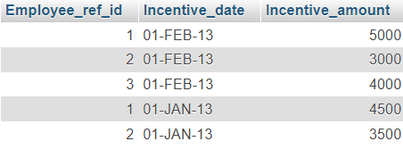

**Get First_Name from employee table using Tom name “Employee Name”.**

* [SELECT](http://localhost/phpmyadmin/url.php?url=https://dev.mysql.com/doc/refman/8.0/en/select.html) * FROM employee WHERE First_name = 'Tom';

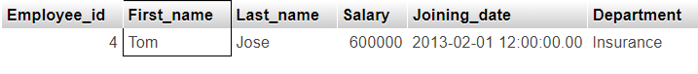

**Get FIRST_NAME, Joining Date, and Salary from employee table.**

* [SELECT](http://localhost/phpmyadmin/url.php?url=https://dev.mysql.com/doc/refman/8.0/en/select.html) First_name, Joining_date, Salary FROM `employee` WHERE 1;

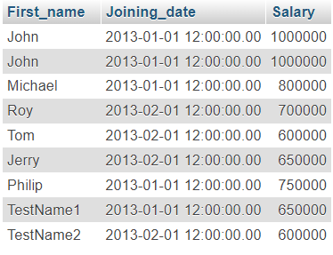

**Get all employee details from the employee table order by First_Name Ascending and Salary descending?**

* [SELECT](http://localhost/phpmyadmin/url.php?url=https://dev.mysql.com/doc/refman/8.0/en/select.html) * FROM employee ORDER BY First_Name ASC, Salary DESC

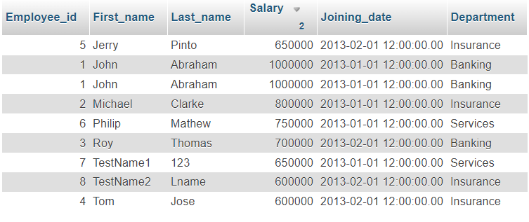

**Get employee details from employee table whose first name contains ‘J’.**

* [SELECT](http://localhost/phpmyadmin/url.php?url=https://dev.mysql.com/doc/refman/8.0/en/select.html) * FROM employee WHERE first_name [LIKE](http://localhost/phpmyadmin/url.php?url=https://dev.mysql.com/doc/refman/8.0/en/string-comparison-functions.html%23operator_like) '%J%';

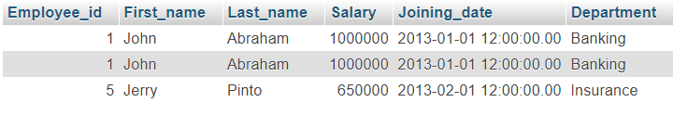

**Get department wise maximum salary from employee table order by salary ascending?**

* [SELECT](http://localhost/phpmyadmin/url.php?url=https://dev.mysql.com/doc/refman/8.0/en/select.html) department, [MAX](http://localhost/phpmyadmin/url.php?url=https://dev.mysql.com/doc/refman/8.0/en/aggregate-functions.html%23function_max)(salary) AS max_salary FROM employee GROUP BY department ORDER BY max_salary ASC;

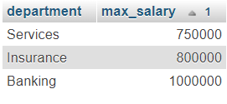

**Select first_name, incentive amount from employee and incentives table forthose employees who have incentives and incentive amount greater than 3000**

* [SELECT](http://localhost/phpmyadmin/url.php?url=https://dev.mysql.com/doc/refman/8.0/en/select.html) e.first_name, i.incentive_amount FROM employee e JOIN incentive i ON e.employee_id = i.Employee_ref_id WHERE i.incentive_amount > 3000;

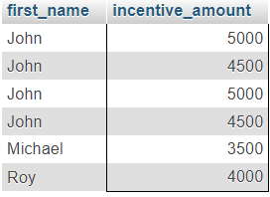

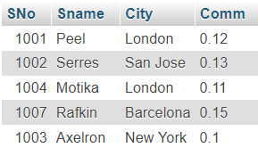 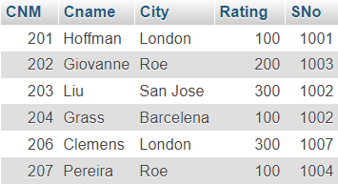

**Names and cities of all salespeople in London with commission above 0.12.**

* [SELECT](http://localhost/phpmyadmin/url.php?url=https://dev.mysql.com/doc/refman/8.0/en/select.html) Sname, City FROM `salesperson` WHERE City = 'London' [AND](http://localhost/phpmyadmin/url.php?url=https://dev.mysql.com/doc/refman/8.0/en/logical-operators.html%23operator_and) Comm > 0.12;



**All salespeople either in Barcelona or in London**

* [SELECT](http://localhost/phpmyadmin/url.php?url=https://dev.mysql.com/doc/refman/8.0/en/select.html) * FROM `salesperson` WHERE City = 'Barcelona' [or](http://localhost/phpmyadmin/url.php?url=https://dev.mysql.com/doc/refman/8.0/en/logical-operators.html%23operator_or) City = 'London';

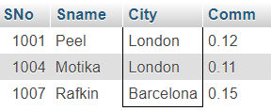

**All salespeople with commission between 0.10 and 0.12. (Boundary values should be excluded).**

* [SELECT](http://localhost/phpmyadmin/url.php?url=https://dev.mysql.com/doc/refman/8.0/en/select.html) * FROM `salesperson` WHERE Comm >= 0.10 [and](http://localhost/phpmyadmin/url.php?url=https://dev.mysql.com/doc/refman/8.0/en/logical-operators.html%23operator_and) Comm <= 0.12;

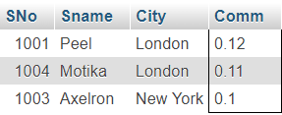

**All customers excluding those with rating <= 100 unless they are located in Rome.**

* [SELECT](http://localhost/phpmyadmin/url.php?url=https://dev.mysql.com/doc/refman/8.0/en/select.html) * FROM customer WHERE (Rating > 100 [OR](http://localhost/phpmyadmin/url.php?url=https://dev.mysql.com/doc/refman/8.0/en/logical-operators.html%23operator_or) City = 'Rome');

